Dehazing and Enhancing Underwater Images

Muhammad Moiz Sajid 19i-0692

TABLE OF CONTENTS

1-Abstract

2-Introduction

3-Problems With Obtaining Underwater Images

4- Our Solution

1. Summary

5- Image Enhancement Steps

1. Contrast Adjustment
2. Image Sharpening
3. Channel Splitting
4. Foreground Extraction to Fine Tune Background
   1. *Image Thresholding and dilation for creating foreground mask*
   2. *Separating foreground and background*
   3. *Background Contrast adjustment*
   4. *Merging Foreground and Background*
5. *Replacing original color channels and converting to RGB*

6- Limitation

7- Some Comparison of images before and after our algorithm applied (without fine tuning the threshold values)

8- Conclusion

B.

ABSTRACT

With the advancement of technology, processing images has become an important tool in the field of entertainment and research. Some domains would be very difficult to research without any sort of processing. An example of one such domain is underwater images.

This paper talks about the challenges that are present when it comes to capturing images below sea level and the steps we used in refining such images using techniques such as contrast stretching, foreground and background extraction, sharpening, etc. The processing was all done on RGB images and made use of the LAB color spectrum for further processing. A dataset was collected and a comparison of before and after is shown to present the efficiency of our algorithm.

I. INTRODUCTION

In recent years, the process of obtaining images has become more accessible to the general public due to the advancements in hardware, software, and algorithms. Digital means have allowed us to efficiently enhance the quality of our images and achieve the desired results. Underwater photography is a field where image enhancement is particularly critical. The unique challenges posed by the way light behaves under the sea, such as reflection, refraction, and diffraction, can create pronounced effects that make identifying simple objects difficult, regardless of the camera's quality. To address these issues, digital image processing techniques such as adjusting contrast, noise, sharpness, etc., must be employed. This project focuses on the algorithms utilized and our justification for selecting them over other alternatives.

II. PROBLEMS WITH OBTAINING UNDERWATER IMAGES

The primary contrast between capturing images on land versus underwater is how light interacts with the environment. On land, light is evenly distributed and objects appear bright when exposed to direct light. However, when underwater, light is reflected off the surface and as we descend further, more red light is absorbed by the surroundings. This results in a blue or green tint that obscures the actual colors of marine life, coral reefs, and rocks. Additionally, the slower speed at which light travels in water impacts the wavelengths and colors visible in underwater images. Objects in the background appear increasingly faded and with a greater intensity of green or blue the farther they are. This distortion of color can pose serious challenges when studying marine life.

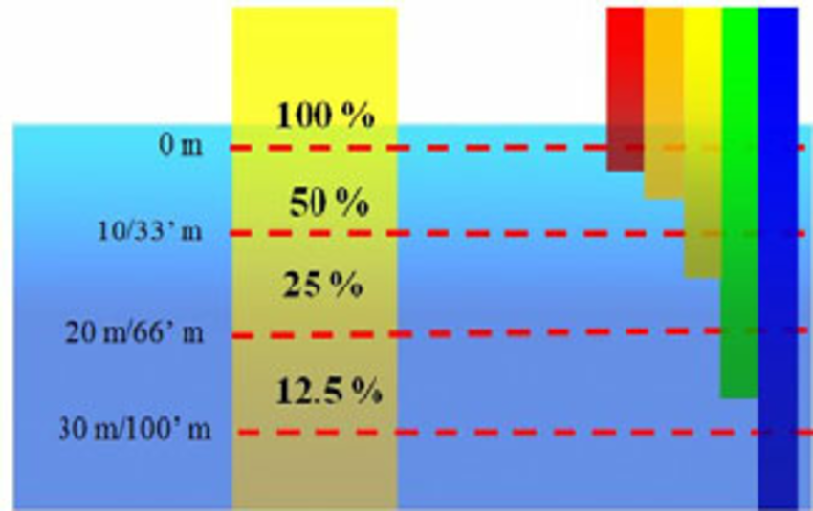

*FIGURE 1: Absorption of different wavelengths of light under different sea depths*

The second major issue with underwater photography is the presence of a hazy filter over the image, which could be caused by taking photos in a polluted area, using unclean lenses, or using low-quality hardware. While wavelength distortion affects color accuracy, a hazy appearance makes identifying objects more difficult. These two issues are the primary reasons why underwater images are often unappealing to the eye.results in a strong blue or green tint forming over the image. This masks the true color of marine life, coral reefs and rocks that are present.

Light travels a lot slower in water as compared to air, and this change in speed in turn affects the wavelength and colors that we can see. This can easily be observed in any underwater image whereas the background goes farther and farther into the distance, objects seem faded out with a deeper intensity of green blue the farther an object is in the background. This distorts the color of the object that is captured and can be a serious issue when studying marine life.

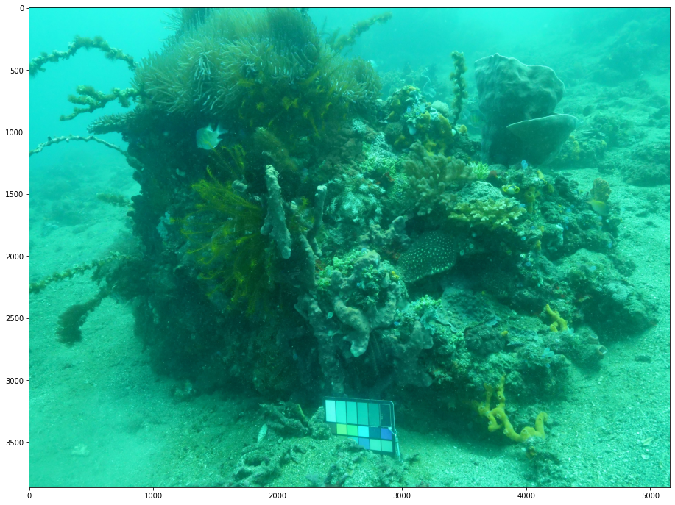

*Figure X: Input Image (Alpha)*

III. OUR SOLUTION

*A. Summary*

To achieve these steps, we utilized a variety of algorithms such as histogram equalization, unsharp masking, and median filtering. These algorithms helped us to improve the quality of the images and highlight important features that were previously difficult to discern. Our final results showed significant improvement in the quality of the underwater images, allowing for better analysis and understanding of marine life and their environment.

All our steps of preprocessing, processing and post processing was obtained in the spatial domain.

IV. Image Enhancement Steps

*A. Contrast Adjustment*

To display a more comprehensive range of colors in our image and avoid dramatic effects, we need to increase its contrast level. This can be achieved by using Contrast Limited Adaptive Histogram Equalization (CLAHE), an alternative to Adaptive Histogram Equalization (AHE) that is effective in enhancing an image's contrast without amplifying high-intensity pixels such as noise. CLAHE operates by processing small sections of an image's pixels at a time, defined by the tile size, and adjusting the slope of the transformation function proportional to the surrounding cumulative distribution function (CDF). A threshold value, known as the clip-value, is set to limit the slope of the CDF before it is calculated, thereby preventing noise amplification. Any values above this threshold are clipped out and equally added to the histogram bins to avoid data loss. The two main parameters of CLAHE are the clip size and tile size, which affect the output image's appearance. Recursive processing can be used if excess values result in undesired artifacts. Overall, CLAHE is a useful technique for enhancing image contrast while minimizing noise amplification.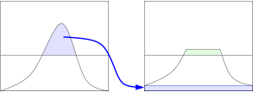

*Figure X: How CLAHE handles high intensity values*

In the case of our dataset of underwater images, we were working in the RGB spectrum. So the CLAHE process had to be performed on each color channel separately.

If we analyze the histograms of R, G, B channels of our original image, we can see the given below histograms

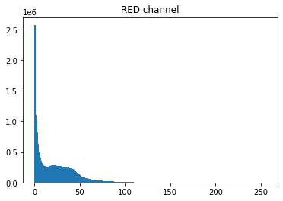 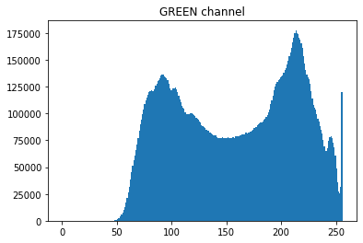 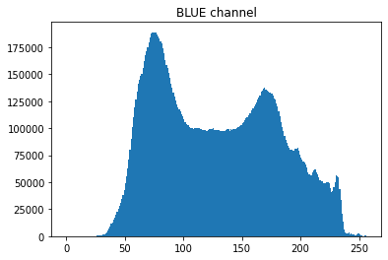

*Figure X: RGB Channels of Input Image*

If we have red channel like in above, we must increase the clip limit and increase the tile size of the red channel in CLAHE function. Resulting histograms after CLAHE of RGB channels of the image

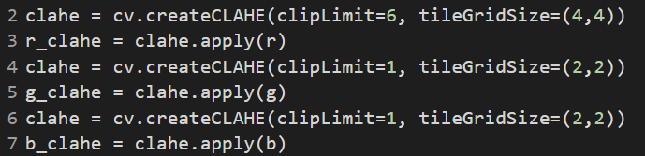

*Figure X: Code for Applying CLAHE on the RGB Channels*

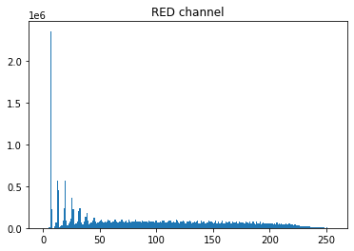 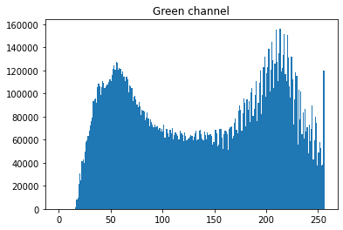 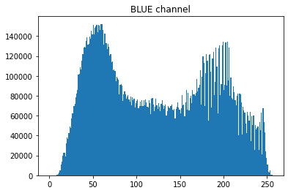

*Figure X: RGB Channels After Applying CLAHE*

Here we can see the contrast has been improved to get some of the original colors of the image. The stretching of the red channel is the most important factor here. Since most deep-sea images are covered with a blue-green tint, stretching the contrast of the red channel brings out more natural colors of objects.

The next step is to join the three channels to get a new image which is more color accurate than our input image.

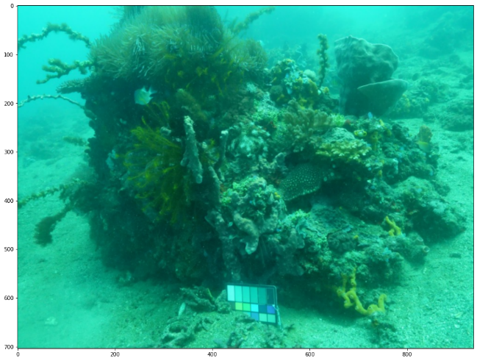 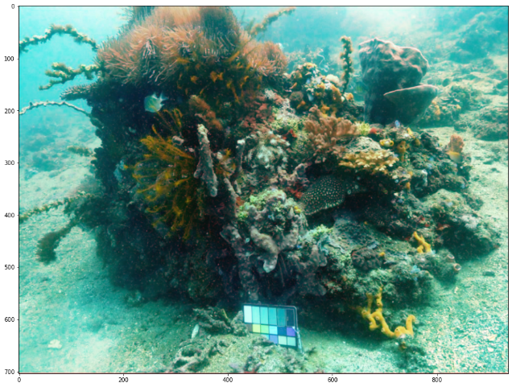

*Figure X: Original image and Image after applying CLAHE*

*B. Image Sharpening*

After improving the colors of the image, we can see some of the details which were previously not that visible. After that we will sharpen the edges of the images obtained in above step to highlight fine details of image for better results.

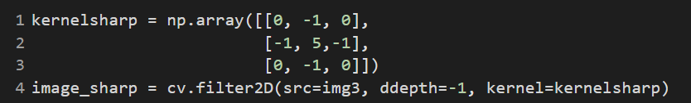

*Figure X: Code for Image Sharpening*

*C. Channels splitting*

After step B we have RGB image whose colors are somewhat restored or better than original image. Here we can see that the image foreground has better image details and background of the image is still hazy, to improve the

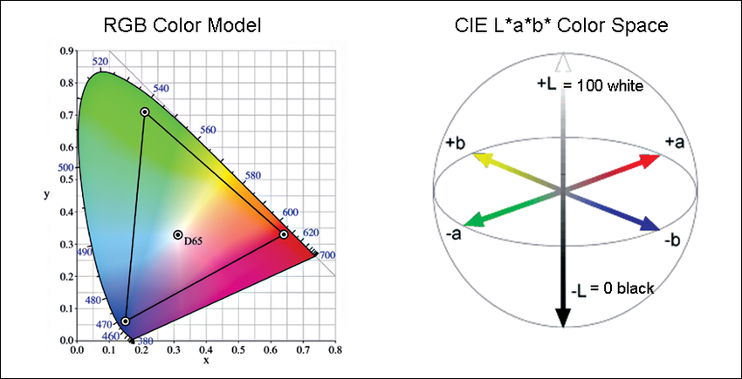

*Figure X: RGB color space and LAB (Lightness, A Channel, B Channel) color space*

background details of the image, we want to work on the background of the image which preserving the colors of the image obtained in step B. The image obtained after step B is in RGB color space. To preserve the colors of the image, we will convert the RGB color space of the image into LAB color space, where L controls the lightness of the image as it returns a grayscale scale if we turn A and B channel to 0 , from its brightness to darkness, A channel preserves reds and greens of the image, and B channel preserves yellows and blues of the image. Here A and B channel can act as slider to shift between reds and greens or yellows and blues w.r.t to the A and B color channels.

*D. Foreground Extraction to Fine Tune Background*

From the step C, using the L channel we will perform the background enhancement. For that we need to implement an algorithm that helps us separate the background from the background. In this step, we will perform following sub steps

*d.1* *Image Thresholding and dilation for creating foreground mask*

We will make a blurred copy of the grayscale image and apply thresholding to create a foreground mask. And using closing morphology, we will fine tune the mask by changing its kernel to better cover background of the image. Sometimes thresholding may fetch the background instead of foreground so we might need to observe the output mask to invert the mask for our area of interest mask.

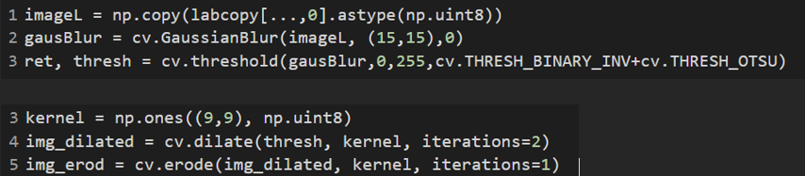

*Figure X: Code for Creating Mask and Dilation*

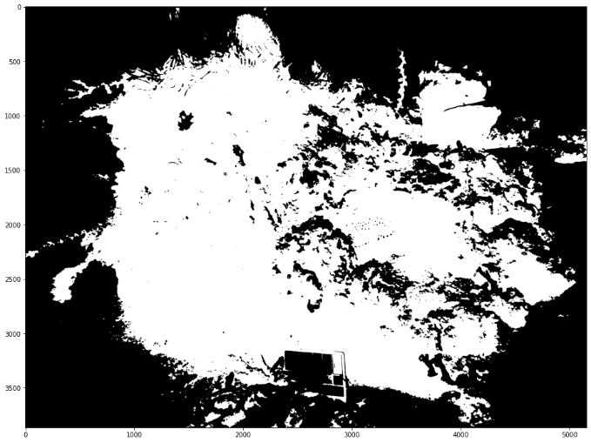 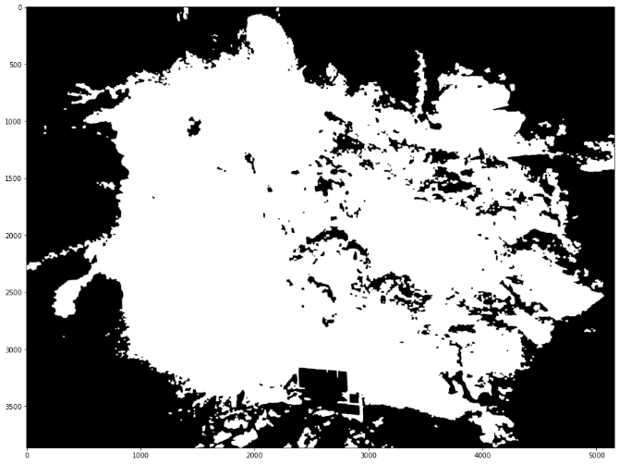

*Figure X: Original Mask and Mask after Dilation*

*d.2 Separating foreground and background*

Using arithmetic operation between mask and grayscale image, we will extract the foreground of the image, so by inverting the mask and arithmetic operation between that inverted mask and image, will give us the background of the grayscale image.

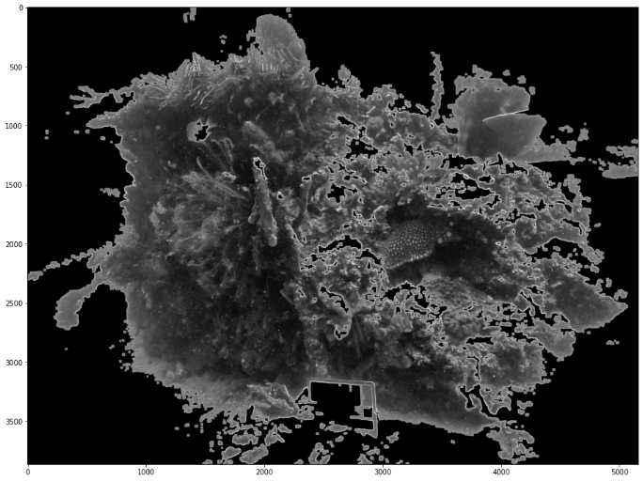 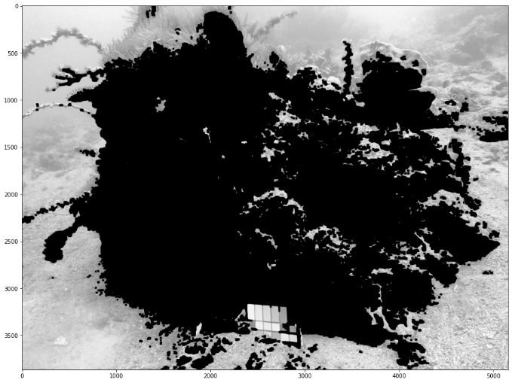

*Figure X: Foreground and Background mask*

*d.3 Background Contrast adjustment*

After the separation of background, we will adjust the contrast of the background to make details appear more clearly. This again can be done via CLAHE by adjusting the clip limit and tile size, so we will perform that. Below can be seen the background before and after its contrast adjustment.

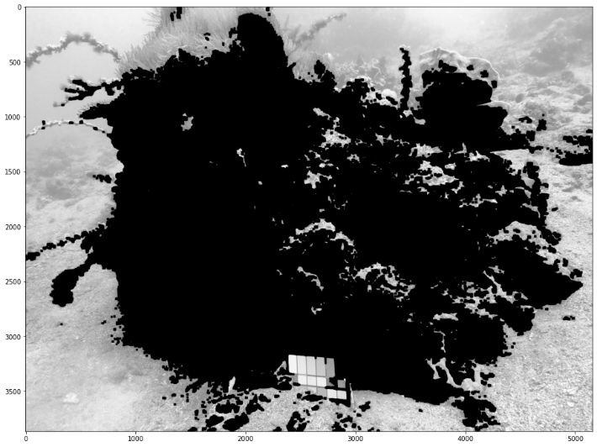 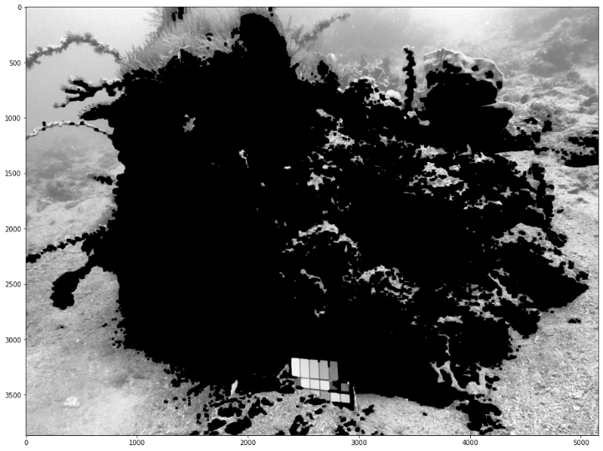

*Figure X: Before and After applying CLAHE on the Background Mask*

*d.4 Merging Foreground and Background*

Here we will merge the foreground and the enhanced background obtained in step d.3 to form enhanced grayscale image with finer details.

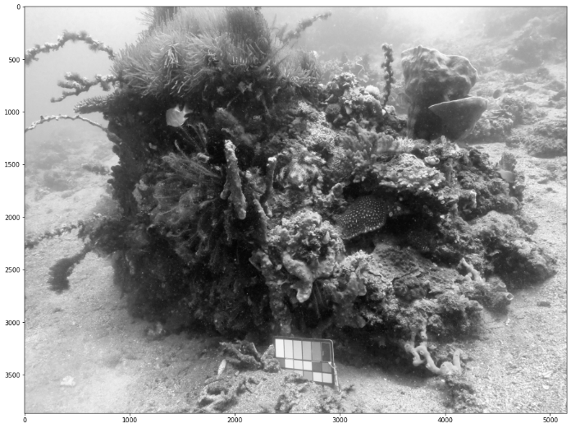 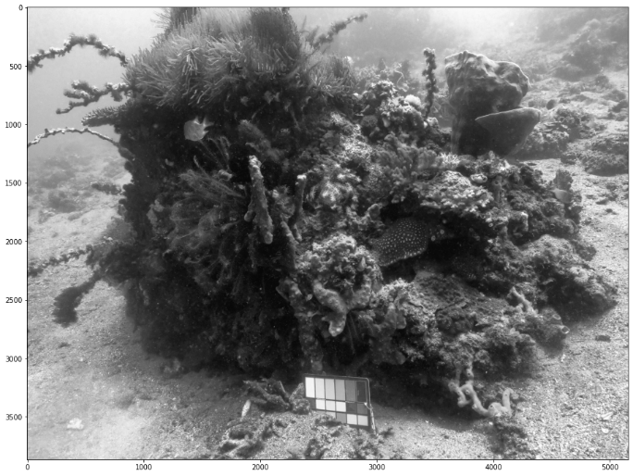

*E. Replacing original color channels and converting to RGB*

In step C, when we converted image to LAB color space, we preserved the A,B color channels by making its copy and converted image to grayscale, which was enhanced in step D, after the enhancing the grayscale image, now we want the image to have its original color channels to save the image to RGB color space. For that we will replace the preserved A and B color channels of the image from LAB color space in step C and convert the image to RGB to get the final enhanced image.

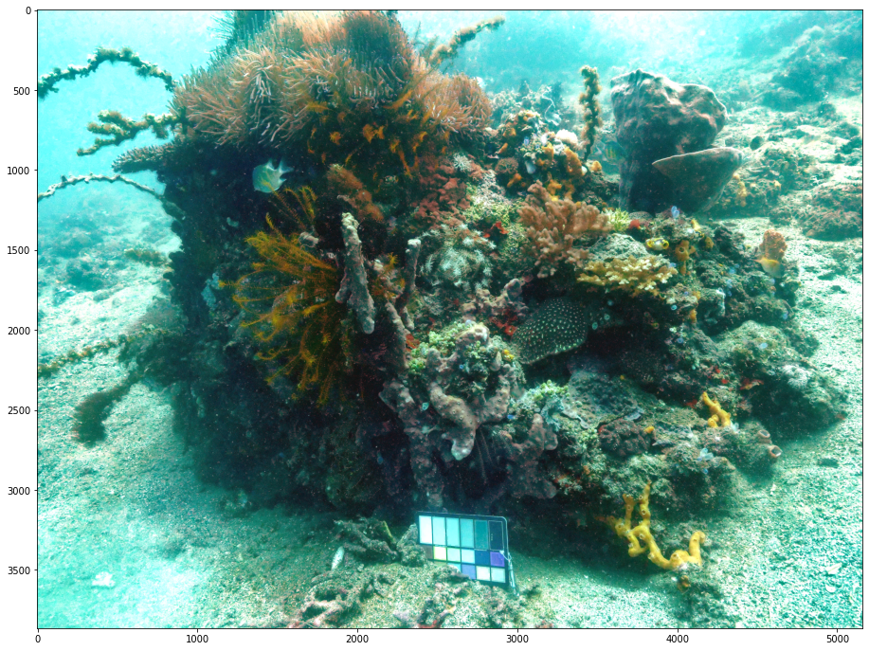

*Figure X: Image (Alpha) Final Output*

V. Limitations

As the algorithm operates entirely in the spatial domain, it has certain constraints in terms of its efficacy. It tends to yield optimal results for images captured at moderate depths and without a heavy greenish tinge. Despite applying CLAHE, certain portions of the image may still not exhibit complete color accuracy. This is because CLAHE employs a region-based approach, where contrast stretching is performed on a specific area. Therefore, if a region contains a limited number of red-channel pixels, the image's blue-green tint will remain dominant.

VI. Some Comparison of images before and after our algorithm applied (without fine tuning the threshold values)

***Input Output***

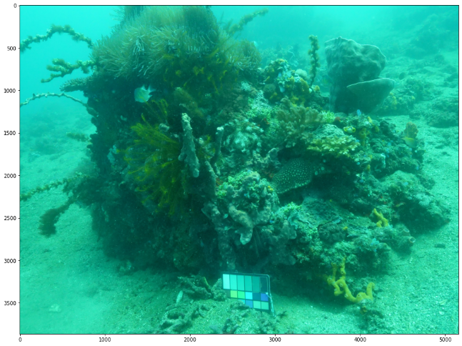 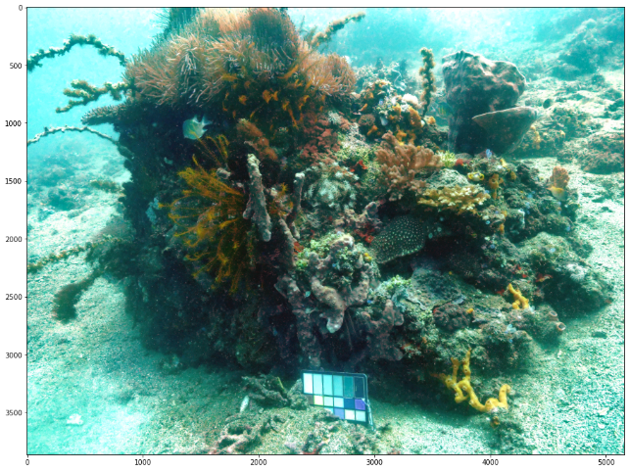

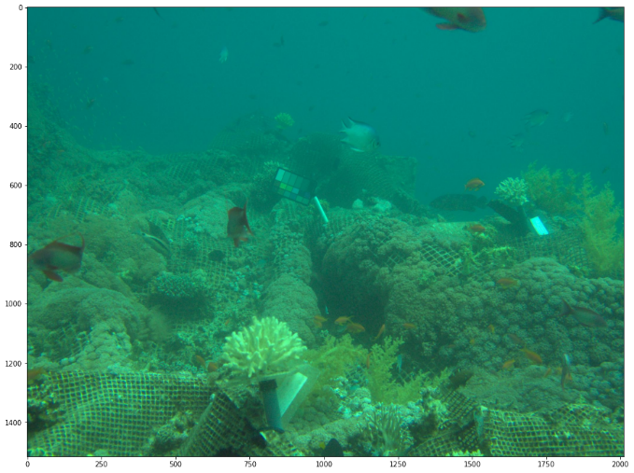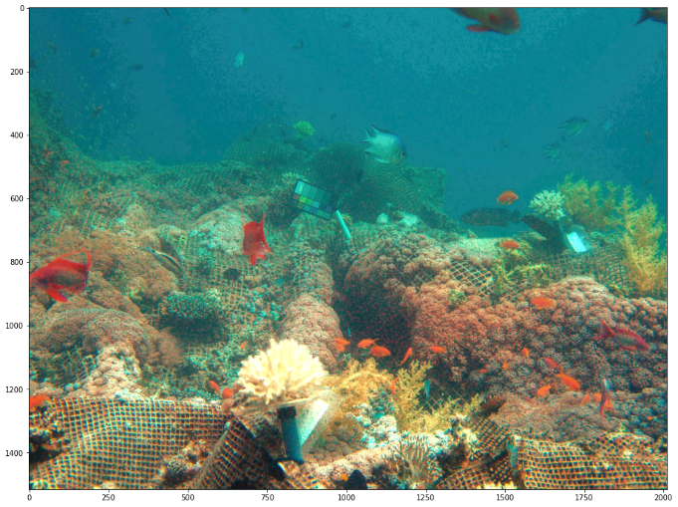

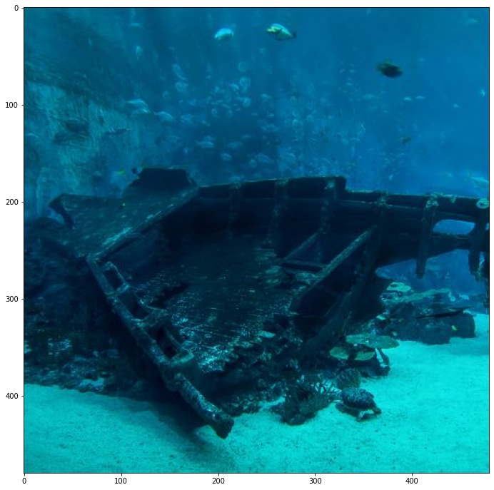 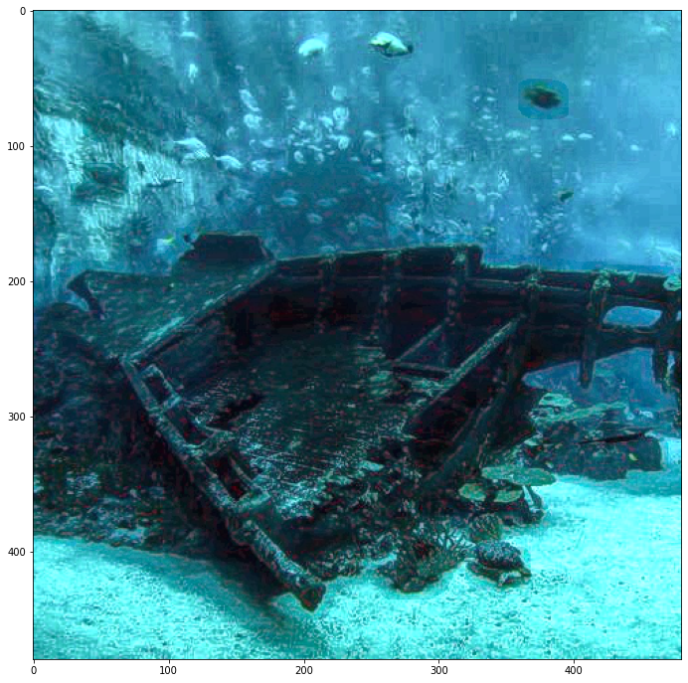

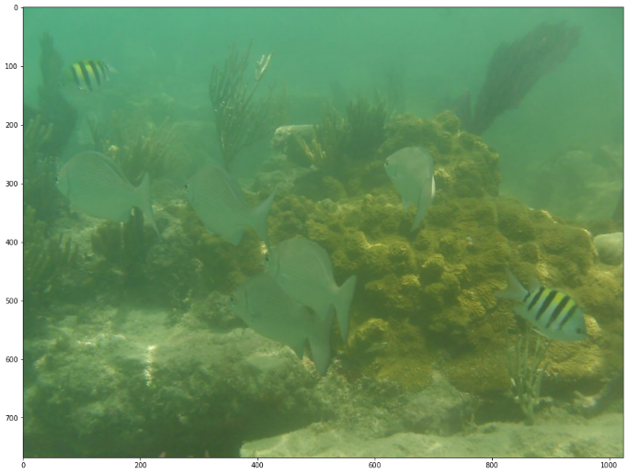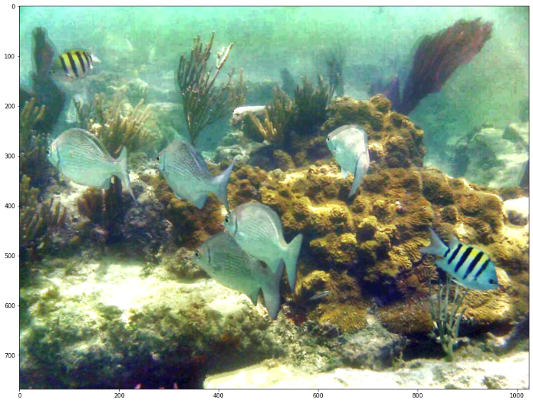

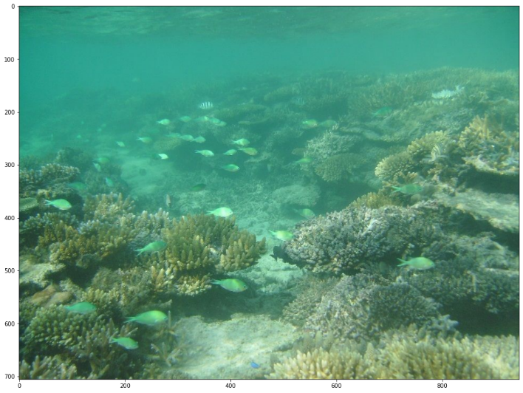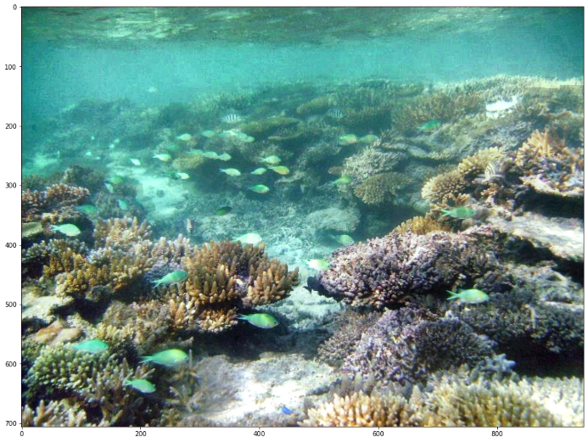

VII. Conclusion

By applying our spatial domain algorithm, significant improvement can be observed in the image, as the issues of hazy filters and inaccurate colors have been successfully addressed. This has led to better identification of individual components of the target object in the image. While other solutions to this problem exist, such as those utilizing machine learning and deep learning algorithms to restore the image to its close-to-real colors, applying these algorithms after our steps can result in a much better image output than currently available solutions.

VIII. References

Thomas Laurent, Underwater image enhancement, https://www.youtube.com/watch?v=KDtyOTUdaUo&ab_channel=ThomasLaurent

Raymond Willy, Sea-Thru: Removing Water from Underwater Images, https://towardsdatascience.com/sea-thru-removing-water-from-underwater-images-935288e13f7d

<https://www.dreamstime.com/photos-images/murky-underwater.html>

CLAHE Histogram Equalization – OpenCV, <https://www.geeksforgeeks.org/clahe-histogram-eqalization-opencv/>

Adaptive histogram equalization, <https://en.wikipedia.org/wiki/Adaptive_histogram_equalization>

<https://www.researchgate.net/figure/Penetration-of-Light-of-Various-Wavelengths-through-Water-Blue-Light-is-the-Strongest_fig3_220785640>